
AIR UNIVERSITY, ISLAMABAD DEPARTMENT OF COMPUTER SCIENCE

ARTIFICIAL INTELLIGENCE
SEMESTER PROJECT

SUBMITTED BY:
NAME | ROLL NO
KHANSA WAHEED | 230982
MOMNA NAWAZ | 230981
AREEBA JILANI | 230904

CLASS: BSIT 6B

INTRODUCTION

Background
With the rise of social media, misinformation spreads faster than verified news. Manual fact-checking is slow, so automated systems are required.

Problem Statement
Existing users cannot easily determine whether a news article is:
- Reliable
- Manipulated
- Completely fake

Objective
To build an AI system that:
- Detects fake news using NLP
- Provides credibility score (0–100)
- Highlights suspicious phrases
- Visualizes analytics

SYSTEM ARCHITECTURE

Architecture Flow
User Input (Text / URL)
→ Flask API Backend
→ NLP Processing Layer
→ ML Model (Best Model: Gradient Boosting / Logistic Regression / Random Forest)
→ Heuristic Engine
→ Domain Credibility Scoring
→ Frontend Visualization Dashboard

Architecture Diagram

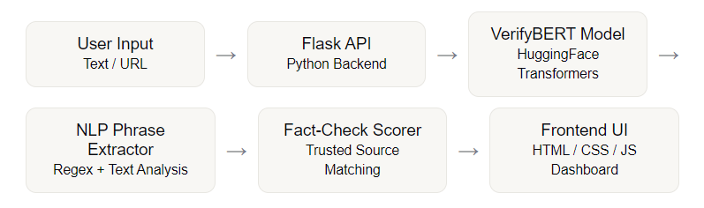

DATASET & PREPROCESSING

Dataset Used

LIAR Dataset (HuggingFace)
- Source: datasets.load_dataset("liar")
- Contains political statements with labels

Label Conversion
Original Labels | Converted
pants-fire | FAKE
false | FAKE
barely-true | FAKE
half-true | REAL
mostly-true | REAL
true | REAL

Feature Engineering
From notebook:
- Word Count
- Character Count
- Exclamation marks
- ALL CAPS words
- Sentence length
- Label distribution

3.4 Preprocessing Steps
- TF-IDF Vectorization
- Stopword removal
- N-grams (1,2)
- Max features: 3000–10000
- Train-test split: 80/20

EXPLORATORY DATA ANALYSIS (EDA)

Key Observations
- Fake news contains:
  - More ALL CAPS words
  - More exclamation marks
  - Shorter sentences
- Real news is:
  - More structured
  - Longer sentences
  - Less emotional tone

MACHINE LEARNING MODELS

Models Used

1. Logistic Regression
- TF-IDF based classifier
- Fast baseline model

2. Random Forest
- Ensemble tree-based model
- Handles nonlinear patterns

3. Gradient Boosting
- Highest performance
- Strong generalization

Model Comparison
Model | Accuracy | Precision | Recall | F1 | AUC
Logistic Regression | 75% | 72.73% | 80% | 76.19% | 0.905
Random Forest | 70% | 62.5% | 100% | 76.92% | 0.895
Gradient Boosting | 80% | 71.43% | 100% | 83.33% | 0.925

Best Model:
Gradient Boosting Classifier

EVALUATION METRICS

6.1 Metrics Used
- Accuracy
- Precision
- Recall
- F1 Score
- AUC-ROC
- Confusion Matrix

HEURISTIC & NLP ANALYSIS

Linguistic Features
The system detects:

Clickbait patterns:
- SHOCKING
- BREAKING
- MIRACLE
- CONSPIRACY

Emotional triggers:
- panic
- outrage
- scandal

Hedging phrases:
- allegedly
- sources say
- apparently

7.2 Domain Credibility Scoring
Example:
Domain | Score
reuters.com | 95
bbc.com | 92
infowars.com | 8

SYSTEM FEATURES

8.1 Core Features
- Fake news classification (REAL/FAKE)
- Credibility score (0–100)
- Highlight suspicious phrases
- Fact-check API links
- Timeline simulation
- Domain reputation scoring

FRONTEND SYSTEM

9.1 Technologies Used
- HTML5
- CSS3
- JavaScript
- Chart.js

9.2 Pages Overview

Home Page

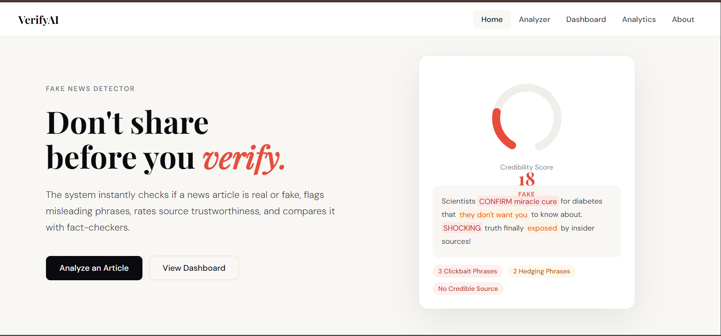

Analyzer Page

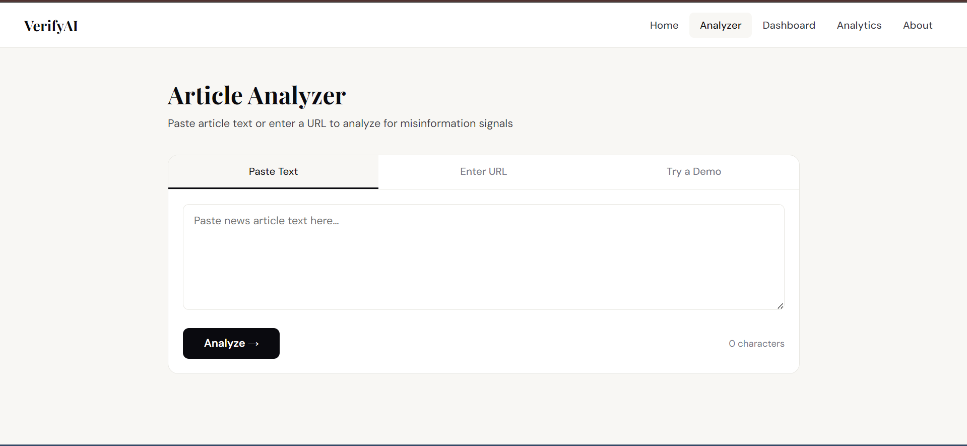

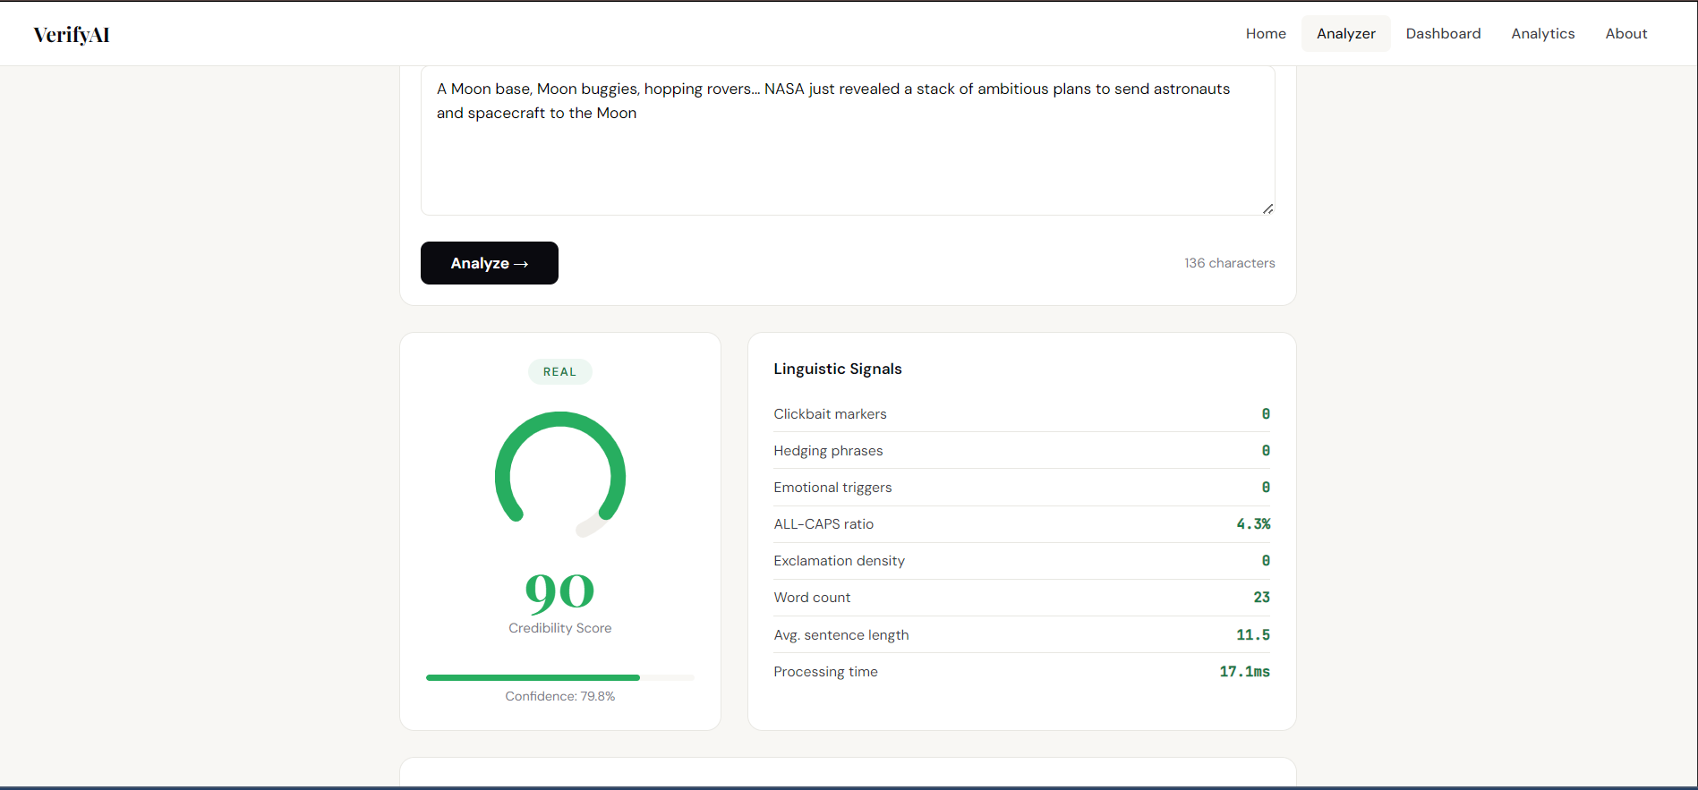

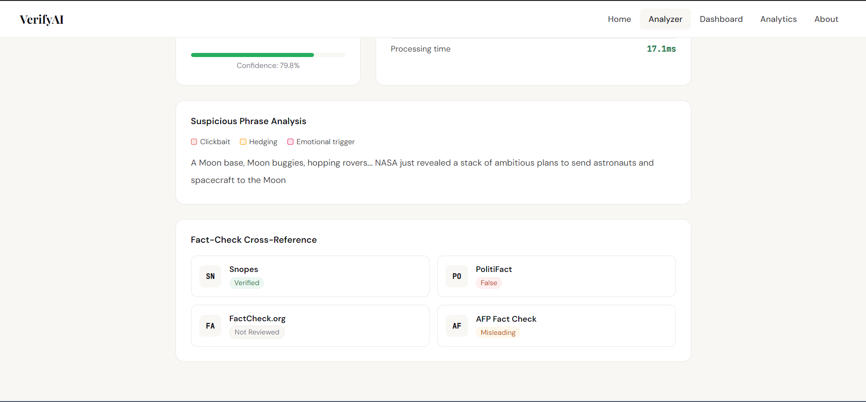

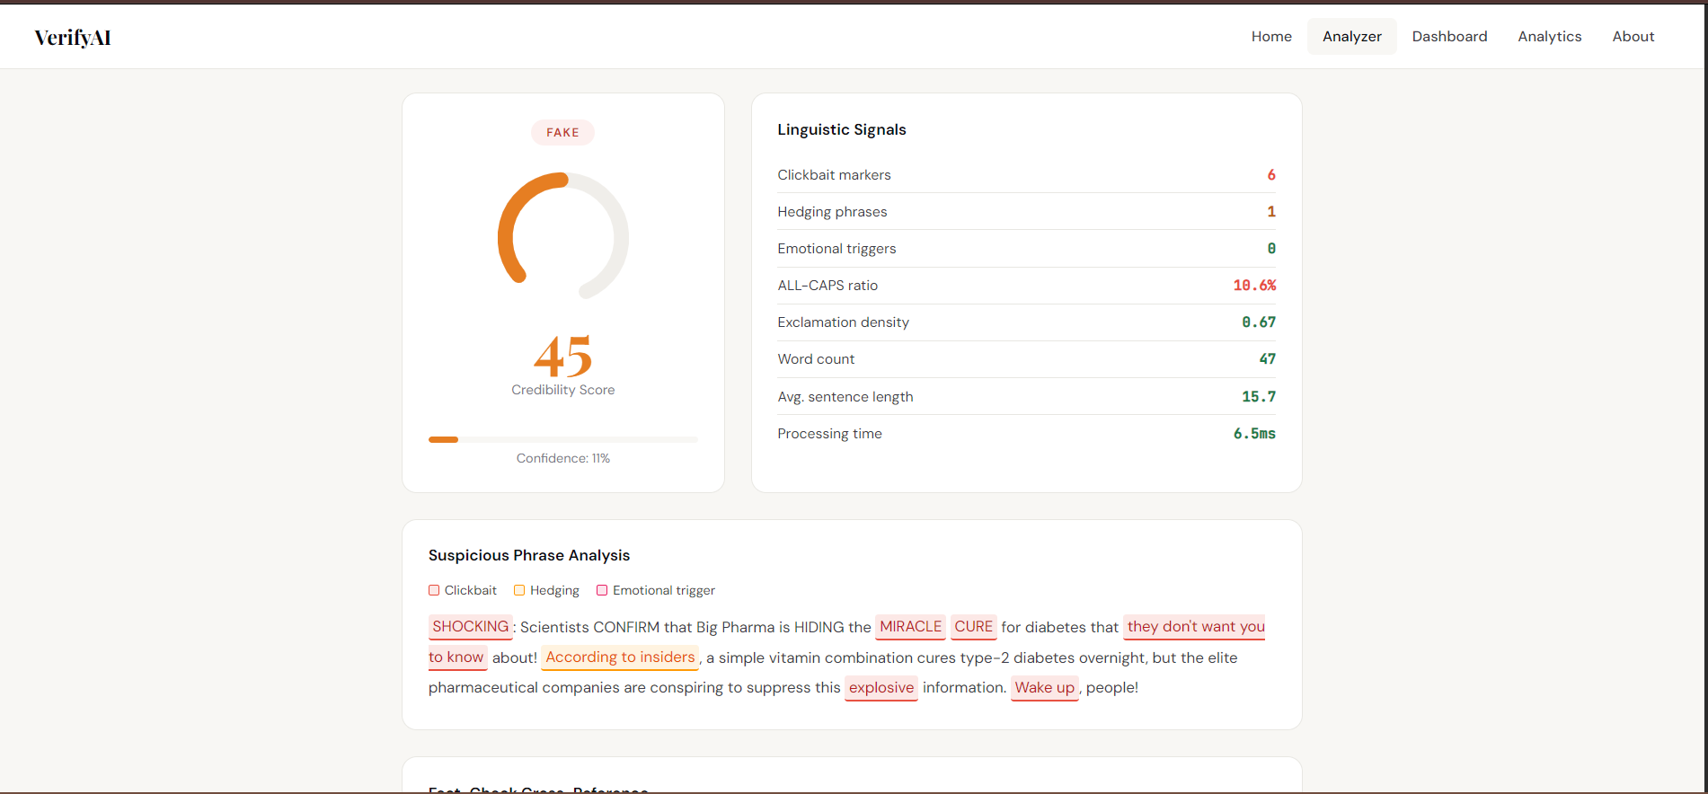

Dashboard

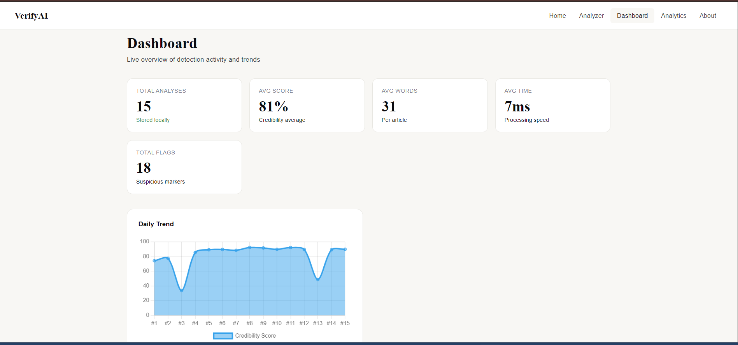

Analytics Page

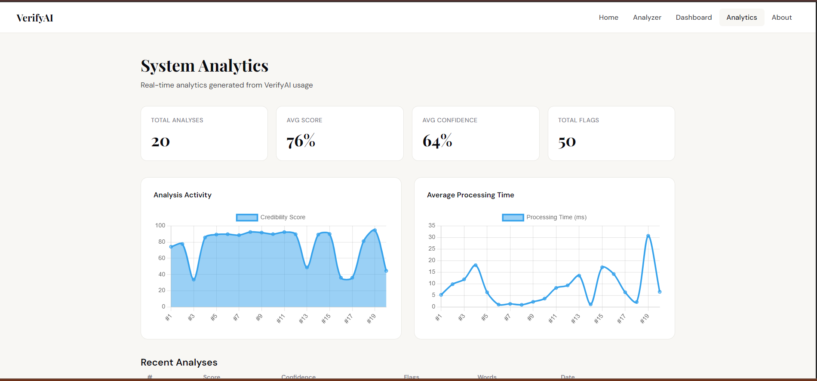

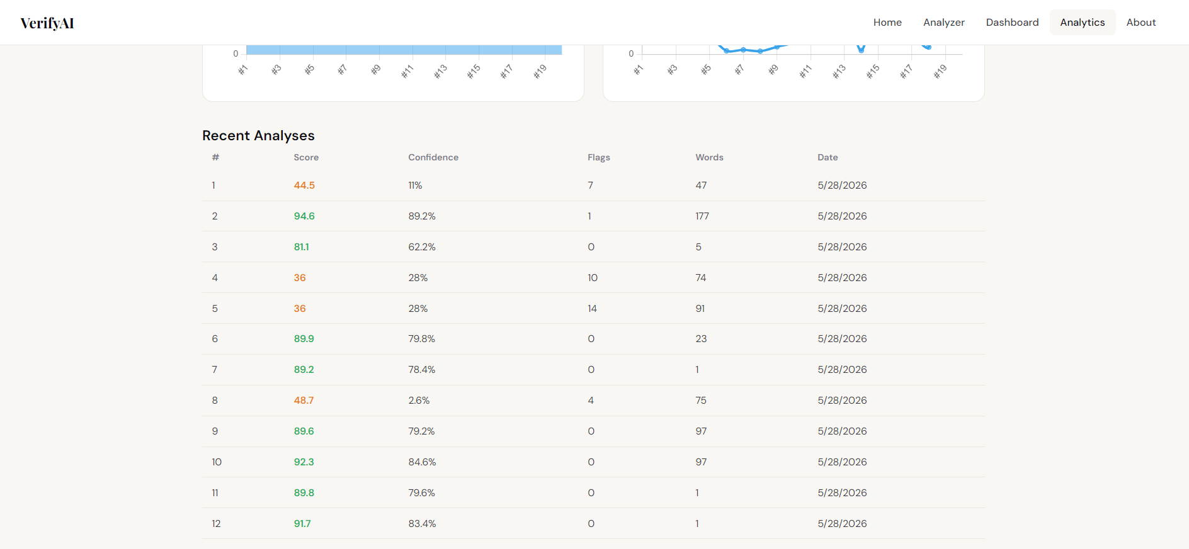

About Page

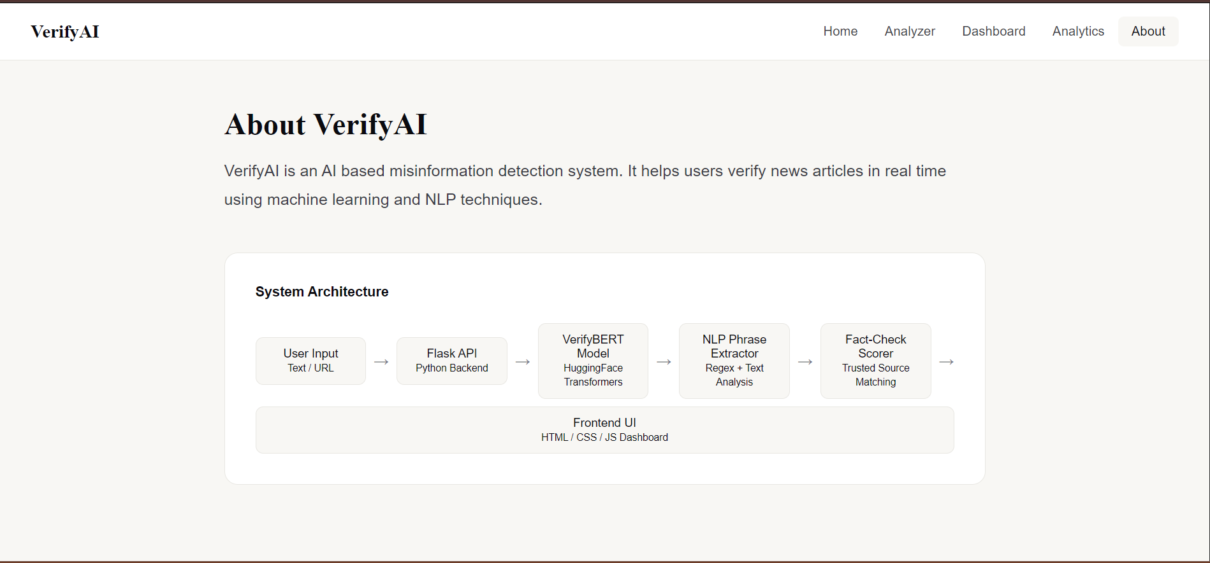

CONCLUSION
The VerifyAI system successfully demonstrates how machine learning and NLP can be used to detect misinformation. The combination of:
- ML models
- Heuristic rules
- Domain scoring
- Fact-check integration
results in a robust fake news detection system.

